Illinois Sentencing Policy Advisory Council

**HOUSE BILL 5219 (AS INTRODUCED)**

103rd General Assembly - Spring 2024

**IMPACT ANALYSIS**

**Summary Information**

**Population Change**

5,700 fewer people in the Illinois Department of Corrections

**Bill Summary**

House Bill 5219 amends the Illinois Code of Corrections to remove all truth-in-sentencing (TIS) restrictions for new and current sentences.

The proposal requires IDOC to recalculate the release date for the current population to align with the proposed changes to truth-in-sentencing.

For a full analysis of changes see page 3.

**Impacts**

## 1. Demographic Impact (Page 6)

52% of Admissions to IDOC are Black

30% of Admissions to IDOC are White

## 2. Fiscal Impact (Page 8)

Total Costs Avoided First Three Years: $104.6 million

Total Overall Costs Avoided: $976.8 million

## 3. Victimization Impact (Page 12)

Additional Victimization Costs: $1.5 million

**spac.illinois.gov**

**Costs Change**

$104.6 million in the first three years and $976.8 million in

overall savings to State

Government

**Outcomes**

House Bill 5219 would decrease the length of stay for people currently subject to TIS restrictions. This reduction is because sentence credits would be available to people who are currently not eligible to have their sentence reduced beyond 75%, 85%, or 100%.

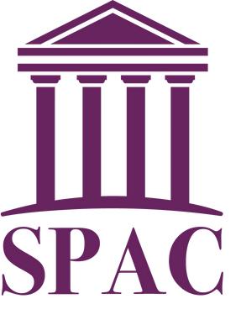

This shorter length of stay would result in fewer people in IDOC.

Victoria Gonzalez

Executive Director

The Sentencing Policy Advisory Council (SPAC) is a statutorily created council that does not support or oppose legislation. Data analysis and research is conducted by SPAC’s research staff. The analysis presented here is not intended to reflect the opinions or judgments of SPAC’s member organizations.

**Illinois Sentencing Policy Advisory Council**

**HOUSE BILL 5219 (INTRODUCED)**

## 730 ILCS 5/3-6-3

## Truth-in-Sentencing and Sentence Credits Impact Analysis

Annual Prison Population Change: **-5,700 People**

Short-Term Net Present Value of Cost Decrease Over Three Years: **$104,621,999**

Total Long-Term Net Present Value of Cost Decrease Over Three Years: **$976,817,925**

## Table of Contents

Introduction 1

Bill Summary 3

Prison Data 5

Prison Population Projection 7

Cost Analysis Summary 8

Cost Analysis Breakdown 10

SPAC Impact Analysis Methodology 13

# Introduction

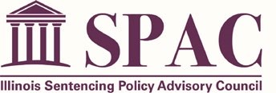The Illinois Sentencing Policy Advisory Council (SPAC) is mandated to review sentencing policies and practices and examine how these policies and practices impact the criminal justice system in Illinois. One of SPAC’s duties is to analyze data relevant to proposed sentencing legislation and its effect on current policies or practices.**[1]** SPAC monitors legislation and prepares impact statements when the data are available, valid, and reliable. These impact statements do not endorse or recommend any particular action on the legislation filed but instead are intended to inform the legislature and the public about the potential impact of legislation on the sentenced population.

This impact statement first summarizes the bill and explains the proposed changes. It then presents data on prison admissions and the population to identify how many persons at each could be impacted by the proposed changes had they been in effect for the past three years. This document then provides a projection on how the prison population would be impacted should the bill go into effect. Finally, SPAC provides a fiscal analysis by identifying cost changes associated if the bill were to

pass. Additional information about our impact analyses, projections, and costs are published in the [2024 Data, Costs, and Baseline Projection for Impact Analyses](https://spac.icjia-api.cloud/uploads/SPAC_2024_ImpactReportsBaseline_posted-20240313T17034926.pdf) document on our website.

# Bill Summary

House Bill 5219 ([HB5219)](https://ilga.gov/legislation/billstatus.asp?DocNum=5219&GAID=17&GA=103&DocTypeID=HB&LegID=153425&SessionID=112), proposes amendments to the Code of Corrections. This proposal eliminates the current truth-in-sentencing (TIS) restrictions that limit the amount of sentence credits people can earn for certain offenses. Under this proposal, except for natural life sentences, sentences that currently require 75%, 85%, or 100% of their sentence to be served in prison would instead be eligible to earn day-for-day credit.

HB5219 also mandates that the Illinois Department of Corrections recalculate the release date for people serving sentences that would be impacted by the legislation. The proposal requires this calculation within six months after the effective date of the proposal. The recalculation would credit individuals with time already served and any remaining time left to serve as if serving a day-for-day sentence. If someone serving a natural life sentence has their sentence reduced to a finite sentence, the person shall be eligible to earn credits toward the new sentence. The proposal also revises language to describe people incarcerated as “incarcerated persons.” Specifically, the proposed amendments are as follows:

* Amends 730 ILCS 5/3-6-3(a)(2) o Replaces the current text with a provision that individuals in custody shall receive one day of sentence credit for each day served in prison except those sentenced to natural life.
* Amends 730 ILCS 5/3-6-3(a)(2.1) o Adds a provision that would require the Department of Corrections, within six months of the effective date, to recalculate each incarcerated person’s release date by crediting them one day of sentence credit for each day served in prison on the current sentence.
  + Restrictions on certain offenses from receiving these credits are eliminated.
* Amends 730 ILCS 5/3-6-3(a)(2.2) o Deletes the provision that persons serving natural life sentences shall receive no credit. o Provides a person serving a natural life sentence would be eligible to receive sentence credit if their sentence is reduced to less than a sentence of natural life, and such credit shall be applied towards that new sentence.
* 730 ILCS 5/3-6-3(a)(2.3), (2.4), (2.5), and (2.6) are all made blank.
* Amends 730 ILCS 5/3-6-3(a)(3) o Adds reference to paragraph (2), expanding eligibility for discretionary earned sentence credits of up to 180 days for those sentenced to less than five years and up to 365 days for those sentenced to five years or longer.
  + Removes reference to paragraph (4.7).
* Amends 730 ILCS 5/3-6-3(a)(4)(A) o Removes restrictions under paragraph (4.7), expanding eligibility to receive sentence credit for completing programs or reentry planning provided by the Department of Corrections.
* 730 ILCS 5/3-6-3(a)(4.7) is made blank.

Table 1 provides a detailed list of changes in HB5219.

**Table 1: Changes to the Code of Corrections Proposed by HB5219**

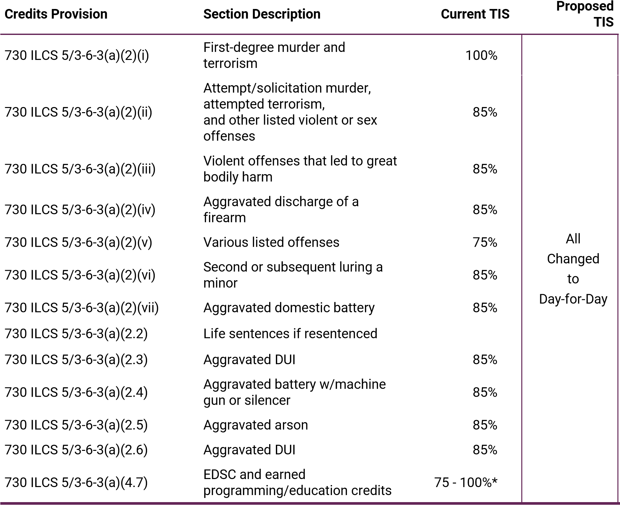

*Those who are currently required to serve 75% of their sentence can reduce their amount of time to serve to 60% through earned discretionary sentence credit and earned program/education credits.

# Prison Data

SPAC used Illinois Department of Corrections (IDOC) data from fiscal years 2021 through 2023 to identify admissions, exits, and the June 30th, 2023 prison population for offenses amended by HB5219, provided in Table 2. Table 3 shows demographics for new court admissions and the prison population that were admitted on a TIS sentence of 75%, 85%, or 100% and would have been impacted by HB5219.

**Table 2: Total FY 2021-2023 TIS Prison Admissions, 2023 Prison Population, Average Jail Credits,**

**Sentence Length, and Length of Stay**

|  |  |  |  |
| --- | --- | --- | --- |
|  |  | **Truth in Sentencing Percentage** |  |
|  | **100%** | **85%** | **75%** |
| Class M Admissions | 482 | 0 | 0 |
| Class X Admissions | 0 | 1,592 | 142 |
| Class 1 Admissions | 0 | 582 | 12 |
| Class 2 Admissions | 0 | 676 | 2 |
| Class 4 Admissions | 0 | 43 | 0 |
| Total Admissions | 482 | 2,893 | 156 |
| Class M Population | 4,255 | 5 | 0 |
| Class X Population | 0 | 6,101 | 274 |
| Class 1 Population | 0 | 1,028 | 8 |
| Class 2 Population | 0 | 782 | 2 |
| Class 4 Population | 0 | 47 | 0 |
| Total Population | 4,255 | 7,963 | 284 |
| Average Jail Credit | 5.3 | 1.9 | 1.4 |
| Average Sentence | 37.9 | 10.4 | 11.1 |
| Average Length of Stay | 13.6 | 6.9 | 6.3 |

Note: Average jail credit and sentence length are from prison admissions and length of stay is from prison exits, all measured in years.

**Table 3: Demographics of TIS Admissions to DOC FY 2021 through FY 2023 and the IDOC TIS Prison Population on 6/30/2023**

|  |  |  |  |  |  |
| --- | --- | --- | --- | --- | --- |
|  | **FY 2021 - 2023 Admissions** | | | **June 30, 2023 Prison Population** | |
| **Characteristic** | **Count** | **Percent** | **Count** | | **Percent** |
| **Race** Black | 1,831 | 51.9% | 6,869 | | 54.9% |
| White | 1,065 | 30.2% | 3,310 | | 26.5% |
| Hispanic | 591 | 16.7% | 2,209 | | 17.7% |
| Other | 44 | 1.2% | 114 | | 0.9% |
| **Sex** Female | 165 | 4.7% | 540 | | 4.3% |
| Male | 3,366 | 95.3% | 11,962 | | 95.7% |
| **Region** Cook | 1,414 | 40.1% | 6,126 | | 49.0% |
| Collar | 444 | 12.6% | 1,531 | | 12.2% |
| Urban | 966 | 27.4% | 2,932 | | 23.5% |
| Rural | 705 | 20.0% | 1,912 | | 15.3% |

**Total** **3,531** **-** **12,502** **-**

Note: Technical violators, consecutive sentences, and sexually dangerous person commitments are excluded.

# Prison Population Projection

The impact of HB5219 on the prison population would be a decrease of about 5,300 people in the first year and a long-term reduction of 7,300 people. This decline can be attributed to shortened lengths of stay resulting from the removal of truth-in-sentencing provisions. Initially, the population would decrease to around 26,000 individuals, as those currently incarcerated would exit prison after fulfilling adjusted sentence credits—modifying their 100%, 85%, and 75% truth-in-sentencing requirements, and allowing day-for-day credits for time served. Subsequently, the population would gradually have a small increase, stabilizing at just under 27,500 individuals.

In calculating the status quo projection, SPAC assumed that admissions, sentences, and IDOC discretionary sentence credit awards would remain consistent with FY 2023 admissions and recent exits. Under HB5219, projected exit dates were recalculated for those with any sentence subject to truth-in-sentencing by adjusting the current projected exit date to reflect the reduction in the projected length of stay. These adjustments can be compared to the current status quo projection in Figure 1.

**Figure 1: SPAC Prison Population Projection - HB5219**

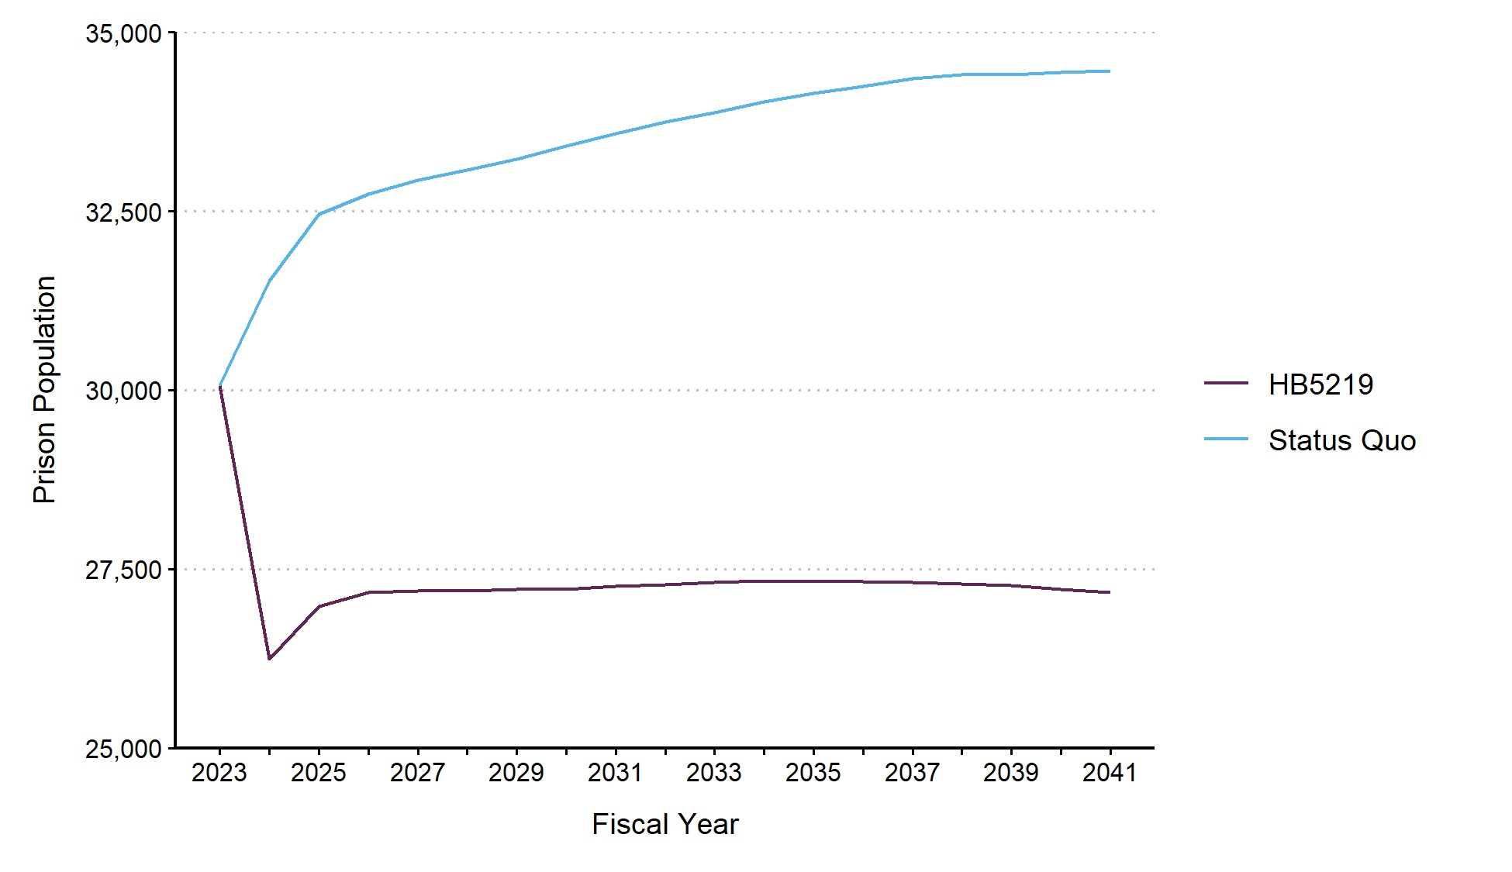

# Cost Analysis Summary

This section broadly shows the SPAC estimates for the total government cost changes had HB5219 been in effect from fiscal years 2021 to 2023. The costs shown in this analysis are the total costs for the complete prison and mandatory supervised release length of stay of individuals admitted to prison in these years and individuals in the prison population on June 30, 2020. **This includes costs for incarceration and supervision within this time frame and in the future, with costs incurred in the future discounted to reflect the time value of money.** More detailed cost analyses are provided in the next section and the methodology section details how SPAC estimated the proposed costs.

Table 4 compares the current costs with the proposed costs had HB5219 been in effect for the last three years. SPAC did not estimate any changes to local costs from HB5219 and therefore this table includes only cost changes for state government. Overall, costs would have decreased by

$978,392,681 under this proposal. Victimizations occurring sooner due to reductions in length of stay in prison were estimated to increase costs by $1,574,756 (see Table 10), and are added to the total difference in this table to produce the estimated net present value decrease of $976,817,925 in costs over the past three years.

**Table 4: Total Government Cost Changes Over Three Years**

|  |  |  |  |
| --- | --- | --- | --- |
| **Group** | **Total Current Cost** | **Total Proposed Cost** | **Total Cost Difference** |
| Admissions | $386,778,170 | $249,971,030 | $136,807,140 |
| Population | $1,673,237,513 | $831,651,972 | $841,585,541 |
| Total | $2,060,015,683 | $1,081,623,002 | $978,392,681 |

Figure 2 shows the costs avoided through fiscal year 2050. Initially, prison costs are avoided but partially offset by the increase in costs for mandatory supervised release that would be required sooner from HB5219. In the short-term, $104,621,999, or 11%, of costs avoided would have occurred in the first three years.

**Figure 2: HB5219 Changes in Cost over Time**

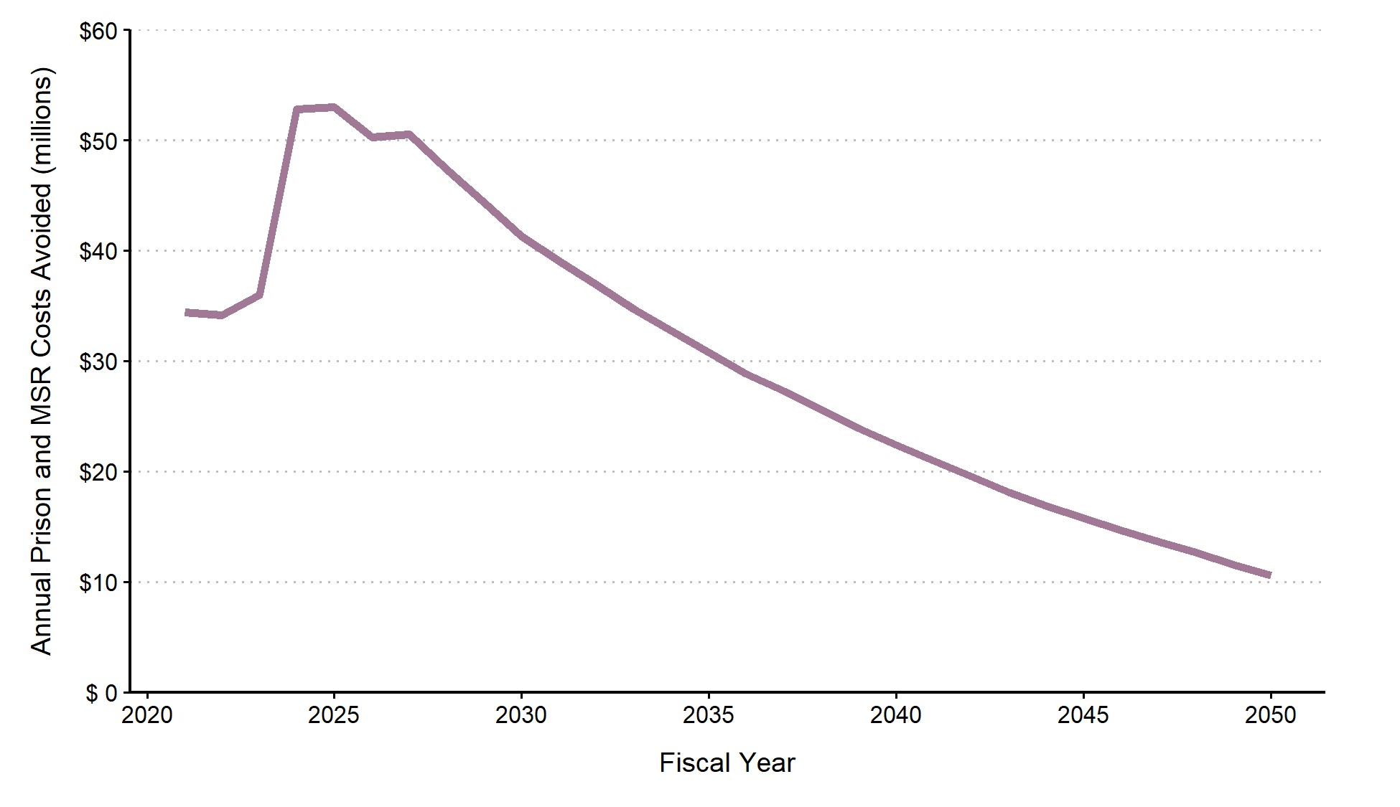

Table 5 breaks down the government cost changes into prison and mandatory supervised release (MSR) cost centers to see the specific change had HB5219 been in effect for the last three years on each cost center. SPAC does not estimate any changes to pretrial (jail) or probation and exclude these from the table.

**Table 5: Government Cost Center Changes**

|  |  |  |  |  |  |  |
| --- | --- | --- | --- | --- | --- | --- |
|  |  | **Admissions** |  |  | **Population** |  |
| **Cost Center** | **Current Cost** | **Proposed Cost** | **Cost Change** | **Current Cost** | **Proposed Cost** | **Cost Change** |
| Prison | $342,845,119 | $200,266,598 | -$142,578,521 | $1,518,094,155 | $630,962,903 | -$887,131,252 |
| MSR | $43,933,051 | $49,704,432 | $5,771,381 | $155,143,358 | $200,689,069 | $45,545,711 |

# Cost Analysis Breakdown

**Impact of Proposed Legislation on County Jails**

Costs avoided over three years: **$0**

SPAC did not estimate any change to county jails population or length of stay.

**Impact of Proposed Legislation on Local Probation**

Costs avoided over three years: **$0**

SPAC did not estimate any change to local probation populations or length of stay.

**Impact of Proposed Legislation on State Prisons**

Costs avoided over three years: **$1,029,709,774**

The estimates in Tables 6 and 7 represent the total prison costs avoided by IDOC that would have occurred had these policies been in place from FY 2021 to 2023 for the admissions during those years and the population beginning in FY 2021. These are net present values and were discounted using a 3% social discount rate. Length of stay is adjusted to reflect mortality given their age at admission for admissions and age on June 30, 2023 for the population. A decrease in the length of stay from the elimination of truth-in-sentencing provisions proposed in HB5219 causes this cost decrease.

**Table 6: DOC Cost Calculation - Admissions**

|  |  |  |  |  |  |  |
| --- | --- | --- | --- | --- | --- | --- |
| **TIS Group** | **Prison Cost** | **Current Sentences** | **Current Avg. LOS** | **Proposed Avg. LOS** | **Current Cost**  **(Discounted)** | **Proposed Cost (Discounted)** |
| 100% | $11,473 | 482 | 29.7 | 15.0 | $106,475,027 | $64,105,728 |
| 85% | $11,473 | 2,893 | 8.1 | 4.3 | $224,807,061 | $128,629,510 |
| 75% | $11,473 | 156 | 6.8 | 4.1 | $11,563,030 | $7,531,360 |

**Table 7: DOC Cost Calculation - Population**

|  |  |  |  |  |  |  |
| --- | --- | --- | --- | --- | --- | --- |
| **TIS Group** | **Prison Cost** | **Current Sentences** | **Current**  **Remaining Avg. LOS** | **Proposed**  **Remaining Avg. LOS** | **Current Cost**  **(Discounted)** | **Proposed Cost (Discounted)** |
| 100% | $11,473 | 4,086 | 24.3 | 8.9 | $811,758,712 | $347,894,399 |
| 85% | $11,473 | 8,341 | 8.5 | 3.2 | $687,393,262 | $275,854,364 |
| 75% | $11,473 | 354 | 4.9 | 1.8 | $18,942,182 | $7,214,140 |

**Impact of Proposed Legislation on State Supervision**

Costs increased over three years: **$51,317,092**

The estimates in Tables 8 and 9 represent the total mandatory supervised release (MSR) costs incurred to IDOC that would have occurred had these policies been in place from FY 2021 to 2023 for the admissions during those years and the population beginning in FY 2021. These are net present values and were discounted using a 3% social discount rate and are censored at six years for those without a projected discharge date. Time spent on MSR is not changed across the current and proposed scenario and is reflective of projected MSR lengths during FY 2021 - 2023, which may currently be shorter. The only cost difference estimated is from the difference of discounted MSR costs based on the timing of when a person is released, which is sooner under HB5219, and is adjusted for mortality.

**Table 8: MSR Cost Calculation - Admissions**

|  |  |  |  |  |  |
| --- | --- | --- | --- | --- | --- |
| **TIS Group** | **MSR Cost** | **Current Sentences** | **Median MSR Period** | **Current Cost**  **(Discounted)** | **Proposed Cost (Discounted)** |
| 100% | $5,074 | 482 | 3 | $2,304,330 | $4,247,760 |
| 85% | $5,074 | 2,893 | 3 | $40,049,433 | $43,751,588 |
| 75% | $5,074 | 156 | 3 | $1,579,287 | $1,705,084 |

**Table 9: MSR Cost Calculation - Population**

|  |  |  |  |  |  |
| --- | --- | --- | --- | --- | --- |
| **TIS Group** | **MSR Cost** | **Current Sentences** | **Median MSR Period** | **Current Cost**  **(Discounted)** | **Proposed Cost (Discounted)** |
| 100% | $5,074 | 4,086 | 3 | $26,072,873 | $50,369,923 |
| 85% | $5,074 | 8,341 | 3 | $124,300,510 | $145,097,968 |
| 75% | $5,074 | 354 | 3 | $4,769,975 | $5,221,179 |

**Impact of Proposed Legislation on Victims and Communities**

Additional Costs over Three Years: **$1,574,756**

Table 10 below provides the costs avoided to victims and the community that would have resulted from HB5219. The proposal would have decreased the length of stay in IDOC, leading to decreased incapacitation benefits and increased recidivism. Additional costs of $1,574,756 would have been incurred, including tangible costs of $723,469 and intangible costs of $851,287.

**Table 10: Victimization Changes - Victimization Cost Increases**

|  |  |  |  |
| --- | --- | --- | --- |
| **Group** | **Tangible**  **Cost Increase** | **Intangible**  **Cost Increase** | **Total**  **Cost Increase** |
| Admissions | $320,132 | $376,691 | $696,823 |
| Population | $403,337 | $474,596 | $877,933 |
| Total | $723,469 | $851,287 | $1,574,756 |

# SPAC Impact Analysis Methodology

SPAC used data from the Illinois Department of Corrections (IDOC) Planning and Research Unit from the past three fiscal years (2021 through 2023) to assess the potential impact of these proposed policies had they been in effect. SPAC used only variable cost changes in the incarcerated and MSR population and did not estimate costs for staffing changes, which may occur with large changes to the populations.

Prison admissions and population data that SPAC analyzed include all sentences associated with an individual’s current holding mittimus, including consecutive sentences under the same mittimus. Notably, the dataset may lack information on additional consecutive sentences under different mittimuses. However, projected release dates consider these additional sentences, irrespective of their mittimus. SPAC assumes consistency in truth-in-sentencing percentages across an individual’s holding mittimus and any unlisted mittimuses, acknowledging potential bias in estimates if these additional sentences were disregarded. We believe the bias would be worse if these additional sentences were ignored.

Changes to truth-in-sentencing laws can yield immediate impacts on the prison population, potentially resulting in a large number of prison exits within the initial year. Conversely, alterations affecting future prison admissions may create smaller short-term effects but could significantly influence the future prison population. Given the time value of money, the analysis factors in the timing of anticipated costs or savings. All future estimated costs for each population member as of June 30, 2020, along with admissions spanning FY 2021-2023, applied a 3% annual social discount rate to compute net present value estimates.

SPAC estimated the impact of HB5219 on lengths of stay as follows:

* Each person admitted to prison or in the prison population had the total length of all their sentences calculated using their projected length of stay, truth-in-sentencing (TIS) percentage and pre-trial detention. This adjustment factored in the estimated length of stay and the truthin-sentencing (TIS) percentage associated with their primary holding offense on the holding mittimus. For instance, if a person’s total length of stay between custody and projected exit was 51 years, and their TIS percentage was 85% on the holding offense, their total sentence under the status quo would be calculated as 60 years (51/0.85).
* Projected lengths of stay and release dates were then adjusted to reflect the elimination of TIS percentages under HB5219, with 50% as the new percentage assumption. Using the previous example, an individual sentenced to 60 years would be estimated to serve 30 years (60x0.5).
* Projected lengths of stay and release dates were adjusted for mortality using recent Centers for Disease Control life tables.**[2]**

* The total cost of incarceration for each person was estimated under the current system and under the reductions from HB5219, with costs discounted in the future using a 3% social discount rate.
* The projected exit date from prison onto mandatory supervised release was changed to reflect the reduced length of stay in prison and the net present costs were re-estimated, with costs discounted in the future using a 3% social discount rate. The vast majority of people on mandatory supervised release are discharged within three years but some offenses involve a post-release supervision period of up to life. All mandatory supervised release terms are capped at 6 years for this analysis.
* The same methodology was applied to the June 30th, 2020 prison population to assess the impact of HB5219 over the past three years, adjusting costs to reflect the remaining time individuals spent in prison.

To calculate changes in victimization, the following steps were taken:

* The age at exit would be younger due to reduced length of stay, which would increase the recidivism rate because recidivism generally declines with age (recidivism benefits). SPAC reviewed historical data to find how recidivism rates changed over age 18 through 60 and applied adjustments based on the age at which people would have exited prison had the bill been in effect.
* The estimates presented here calculate the benefits due to changes in recidivism for two age groups exiting prison: people under 26, who have increasing recidivism rates with decreased age and people older than 26, who exhibit more smaller increases in recidivism rates. Because these age groups’ recidivism rates changed fairly consistently across crime types, felony classes, and gender, SPAC found these methods reasonable for calculating changes in recidivism due to sentencing changes. Th[e SPAC Victimization Supplement](https://spac.icjia-api.cloud/uploads/Victimization_Supplement_0415-20191127T15023943.pdf) further describes the methodology.
* Future crimes are delayed because people are incapacitated, meaning crimes may occur earlier or later because of the timing of their release (Incapacitation Benefits). SPAC applied a 3% discount rate to victimization under the different incapacitation lengths to estimate a possible cost from incurring the costs of victimization sooner due to reduced length of stay in prison.

*The Sentencing Policy Advisory Council (SPAC) is a statutorily created council that does not support or oppose legislation. Data analysis and research is conducted by SPAC’s research staff. The analysis presented here is not intended to reflect the opinions or judgments of SPAC’s member organizations.*

1. 730 ILCS 5/5-8-8.

   103rd IL General Assembly – Spring 2024 1
2. Arias E, Xu JQ, Tejada-Vera B, Murphy SL, Bastian B. U.S. state life tables, 2020. National Vital Statistics Reports; vol 71 no 2. Hyattsville, MD: National Center for Health Statistics. 2022. DOI[: https://dx.doi.org/10.15620/cdc:118271.](https://dx.doi.org/10.15620/cdc:118271)